University of Puerto Rico

Mayagüez Campus

Mayagüez, Puerto Rico

**Phase 2 Report**

Professor: Manuel Rodríguez

ICOM 5016 - 036

November 11, 2013

Made by group: NvByte

Composed of: Christian Vázquez, Pedro Colón, and Alberto Ríos

**Tables**

* Address (addressId: int(11), Line1: varchar(100), Line2: varchar(100), City: varchar(50), State: varchar(2), Zipcode: varchar(5), Country: varchar(50), userId: int(11))
  + Table that contains addresses linked to the user with id userId.
* Admins(adminId: int(11), username: varchar(20), firstName: varchar(50), lastName: varchar(50), password: varchar(20), email: varchar(50), age: int(3))
  + Table with all administrators and their information.
* Bank Accounts(bankAccountID: int(11), accountNum: int(11), userId: int(11))
  + Table with bank accounts and the user they are linked to.
* Baskets(basketId: int(11), bName: varchar(50), userId: int(11))
  + Table of “baskets” or shopping carts and the user to which they are linked.
* Bids(bidId: int(11), amount: double, bidTime: datetime, userId: int(11), bidEventId: int(11))
  + Table with bids made by userId to bidEventId.
* Bid Events(bidEventId: int(11), startingBid: double, startingTime: datetime, endingTime: datetime, description: varchar(255), soldBy: int(11), productId: int(11), basketId: int(11), minBid: double, bidTitle: varchar(50), picture: blob, winningBid: int(11), accepted: int(1), bidcategory: int(11))
  + Table of all instances of auctions with seller soldBy, product productId, the current winning bid winningBid, and belongs to category with id bidcategory.
* Buy Events(buyEventId: int(11), price: double, sellingTime: datetime, description: varchar(255), soldBy: int(11), productId: int(11), bTitle: varchar(50), picture: blob, available: int, buycategory: int(11))
  + Table of instances of sales with seller soldBy, selling product with id productId, and belongs to category with id buycategory.
* Categories(categoryId: int(11), name: varchar(50), parentCategoryId: int(11))
  + Tables of the categories and their respective parent categories.
* Credit Cards(cardId: int(11), cardNum: varchar(16), secCode: varchar(3), expMonth: int(2), expYear: int(2), name: varchar(50), userId: int(11), bankAccount: int(11), billingId: int(11))
  + Table of credit cards from user with id userId, and billing address with id billingId.
* Deal of the day(dotdId: int(11), title: varchar(30), buyEventId: int(11), dayOfSale: date)
  + Table that contains a list of deals of buy events. These are cosen depeding on the purchase history of the user.
* In Bid Basket(basketId: int(11), bidEventId: int(11))
  + Table of the relationship in bid basket that relates basket with the bid events in it.
* In Buy Basket(basketId: int(11), buyEventId: int(11), item_quantity: int)
  + Table of the relationship in buy basket that relates basket with the buy events in it. Item quantity is the number of products to be bought.
* Manufacturers(manufacturerId: int(11), mName: varchar(20))
  + Table of manufactures and their names.
* Orders(orderId: int(11), amount: double, orderTime: datetime, userId: int(11), bankAccountId: int(11), cardId: int(11), basketId: int(11), type: varchar(3), shipTo: int(11))
  + Table of orders with all their information, the user that order it with id userId, the bank account to which the payment will be made, the credit card id used to pay, the id of the basket that is being paid and the shipping address to which it will be sent.
* Products(productId: int(11), sellerPId: int(11), features: varchar(255), dimensions: varchar(255), manufacturerId: int(11), categoryId: int(11), width: double, depth: double, height: double)
  + Table with all the products, their information and the id to their manufacturers.
* Product Reviews(productReviewId: int(11), title: varchar(50), rating: int(2), content: varchar(255), userId: int(11), productReviewedId: int(11))
  + Table of all reviews towards products with the ids of the user who summited it and the product that it’s reviewing.
* Reviews Bid Event(productReviewId: int(11), bidEventId: int(11))
  + Table of reviews towards instances to individual products being auctioned.
* Reviews Buy Event(productReviewId: int(11), buyEventId: int(11))
  + Table of reviews towards instances to individual products being sold.
* Users(userId: int(11), username: varchar(20), firstName: varchar(50), lastName: varchar(50), password: varchar(20), email: varchar(50), age: int(3), birthday: date, rating: int(1))
  + Table of all users with their individual information.
* User Reviews(userReviewId: int(11), rating: int(1), userId: int(11), userReviewedId: int(11))
  + Table of all reviews towards users with the ids of the user who summited it and the user that it’s reviewing.

**Task Analysis**

**Users**

**Creating an Account**

1. To create an account the new user should open the app and select the link that says “Create Account”.
2. In the registering screen the user has to fill all the data needed which includes: username, email, password, first and last name, birthday, shipping address, credit card information and the billing address of the entered credit card.
3. Finally press the “Create Account” button to submit the information.

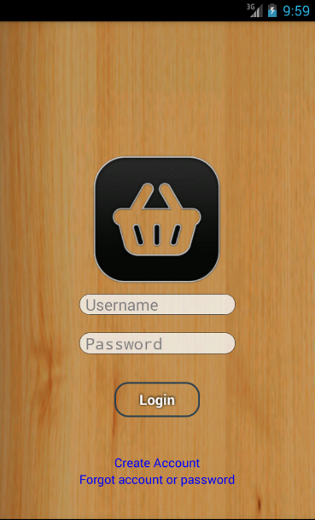 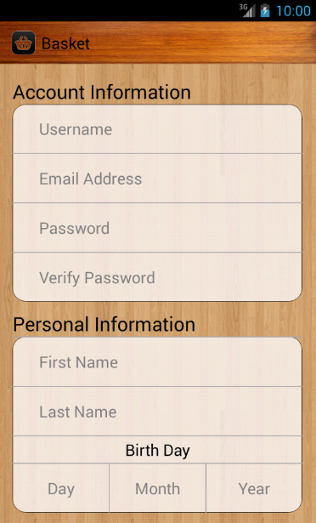 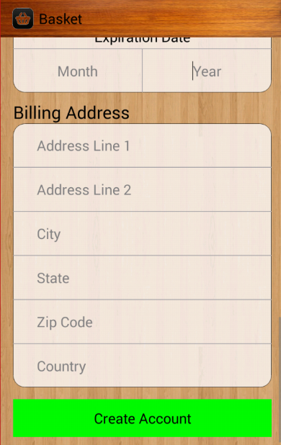

**Recovering forgotten username or password**

1. On the login screen select the "Forgot account or password" link.
2. Then enter the email used to register the account on the text field.
3. Finally press the button on the bottom.

 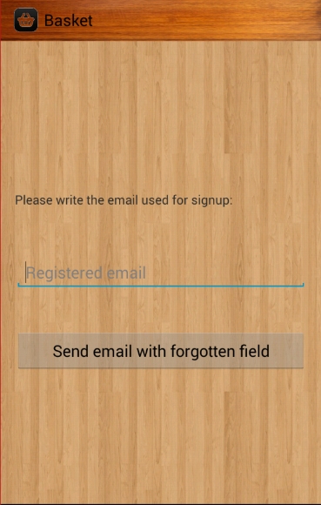

**Searching for products**

1. Login with a valid account username and password.
2. On the homepage swipe to the right or touch the Basket action button to open the side menu. Select the "Search products" option.
3. On the search screen swipe to the right to open the filters and sorting options menu.
4. Select your desired options by swiping to the sides.
5. Close the side menu and now enter a search word on the search bar and touch the search icon on the right side.

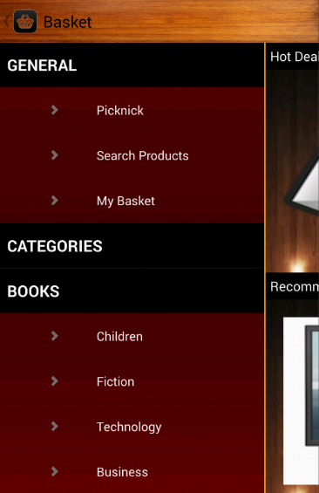 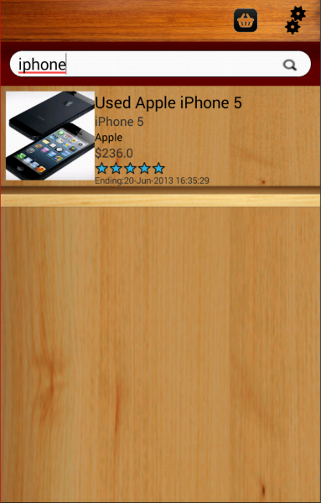 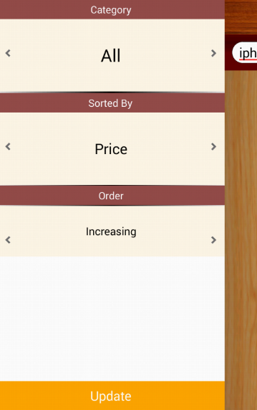

**Changing profile information**

1. Login with a valid account username and password.
2. On the homepage swipe to the right or touch the Basket action button to open the side menu.
3. Select the Picknick option.
4. On the Picknick screen select the My Profile option.
5. On the Profile screen to change username, password or email just select the desired field, change its value and touch the icon to the right in the text field to update it.

 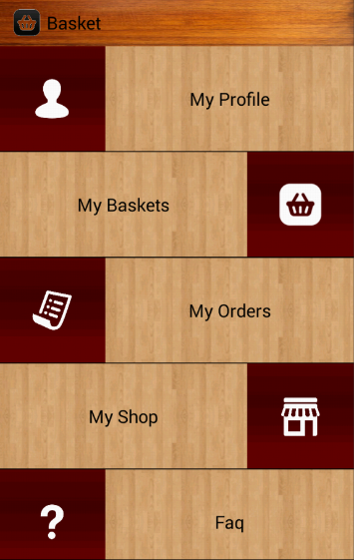 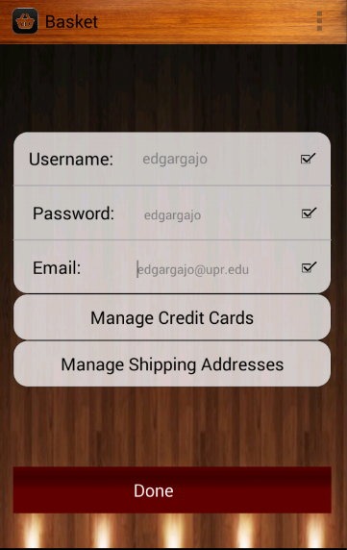

**Managing credit cards**

1. Login with a valid account username and password.
2. On the homepage swipe to the right or touch the Basket action button to open the side menu.
3. Select the Picknick option.
4. On the Picknick screen select the My Profile option.
5. To manage credit cards select the "Manage Shipping Addresses" button.
6. In the Manage Credit Cards screen a new credit card can be added by selecting the "Add New Credit Card" button on the bottom of the screen.
7. To edit a credit card and its corresponding billing address select the credit card to be edited.
8. On the credit card edit screen select the field from the credit card or billing address to be edited, make the desired changes and select "Save" otherwise select "Cancel" to cancel the changes made.

  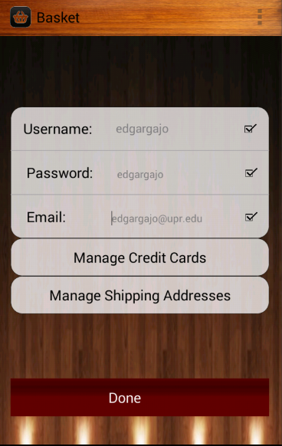

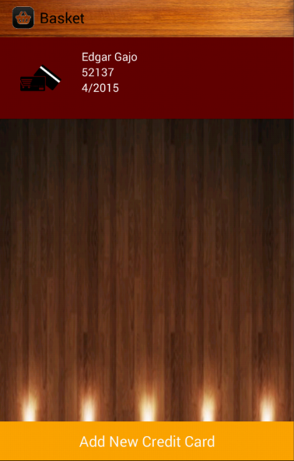 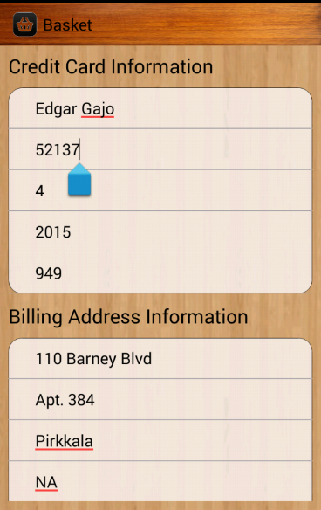 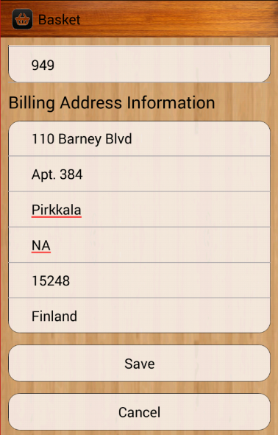

**Managing shipping addresses**

1. Login with a valid account username and password.
2. On the homepage swipe to the right or touch the Basket action button to open the side menu.
3. Select the Picknick option.
4. On the Picknick screen select the My Profile option.
5. To manage shipping addresses select the "Manage Shipping Addresses" button.
6. In the Manage Shipping Addresses screen a new shipping address can be added by selecting the "Add New Shipping Address" button on the bottom of the screen.
7. To edit a shipping address select the shipping address to be edited.
8. On the shipping address edit screen select the field to be edited, make the desired changes and select "Save" otherwise select "Cancel" to cancel the changes made.

  

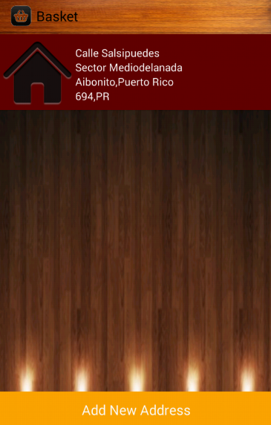 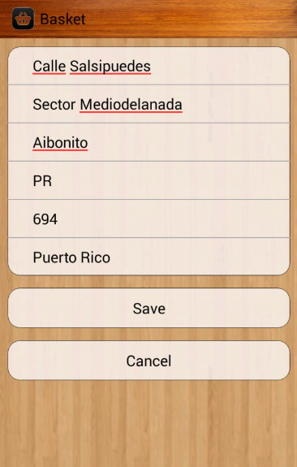

**Viewing and editing baskets**

1. Login with a valid account username and password.
2. On the homepage swipe to the right or touch the Basket action button to open the side menu.
3. Select the Picknick option.
4. On the Picknick screen select the My Baskets option.
5. To change between baskets use the tabs on top.
6. To remove a product from a basket touch in the down arrow on the right until the quantity reaches 0.
7. To add more of a product touch the up arrow.

  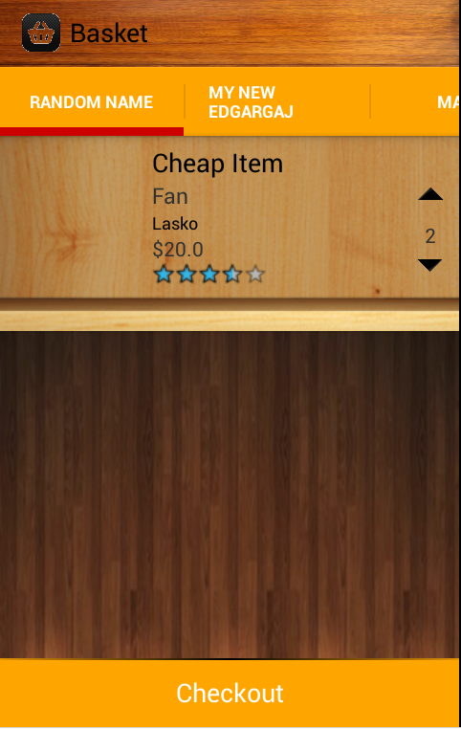

**Adding or Removing baskets**

1. Login with a valid account username and password.
2. On the homepage swipe to the right or touch the Basket action button to open the side menu.
3. Select the Picknick option.
4. On the Picknick screen select the My Baskets option.
5. To change between baskets use the tabs on top.
6. To remove a basket press the button at the top right corner of the screen and select “Delete Basket”.(The button can be the device’s menu button)
7. To add a basket press the button at the top right corner of the screen and select “Add Basket”, then enter the name of the new basket.

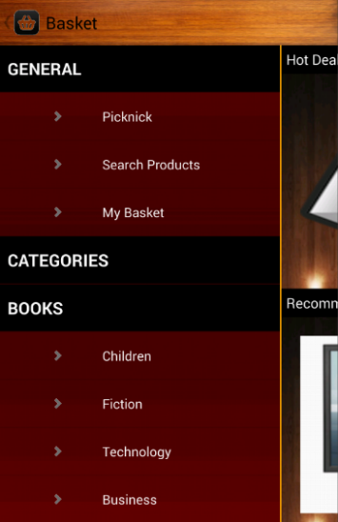 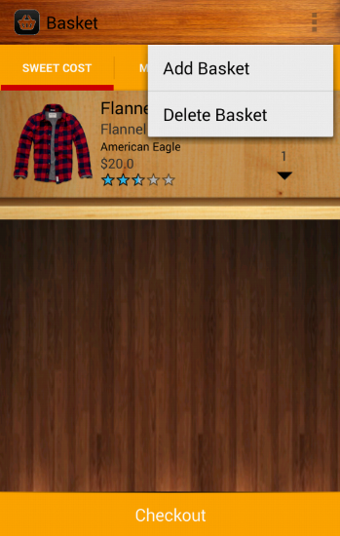 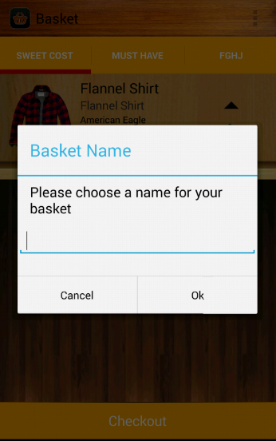

**Paying for baskets**

1. Login with a valid account username and password.
2. On the homepage swipe to the right or touch the Basket action button to open the side menu.
3. Select the Picknick option.
4. On the Picknick screen select the My Baskets option.
5. To change between baskets use the tabs on top.
6. To pay for a basket touch the basket button on the bottom of the screen.
7. On the checkout page select the credit card to be used to pay, the shipping address where the products will be sent, and finally complete the order by touching the "check out" button.

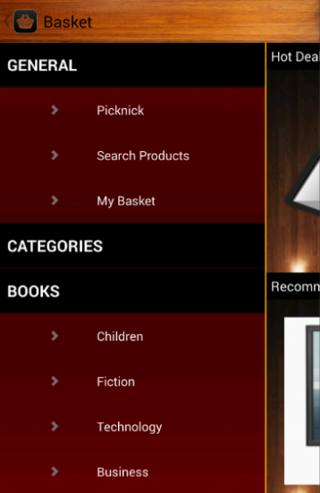 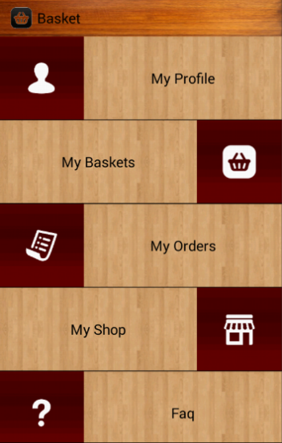 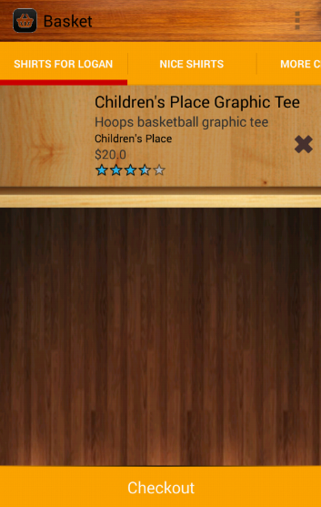 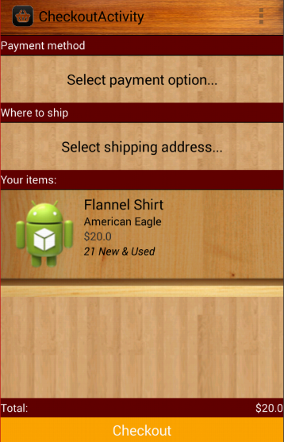

**Viewing orders made**

1. Login with a valid account username and password.
2. On the homepage swipe to the right or touch the Basket action button to open the side menu.
3. Select the Picknick option.
4. On the Picknick screen select the My Orders option. In the orders screen switch between orders by selecting tabs on the top.
5. Every order tab displays the time it was made, the address it was shipped to, the credit card it was paid with, and the product that were on the basket paid.

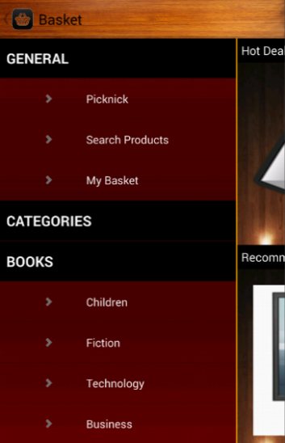  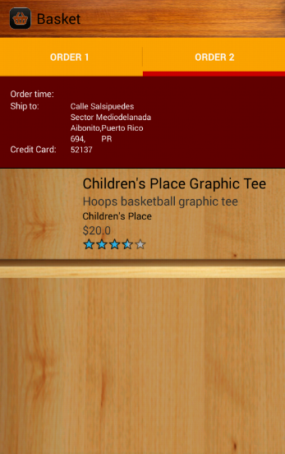

**Viewing bids made**

1. Login with a valid account username and password.
2. On the homepage swipe to the right or touch the Basket action button to open the side menu.
3. Select the Picknick option.
4. On the Picknick screen select the My Shop option.
5. Select the "Bidding Items" tab to see all the bids made.
6. To refresh the list pull the list down. If a product was won it will appear after refreshing the list.

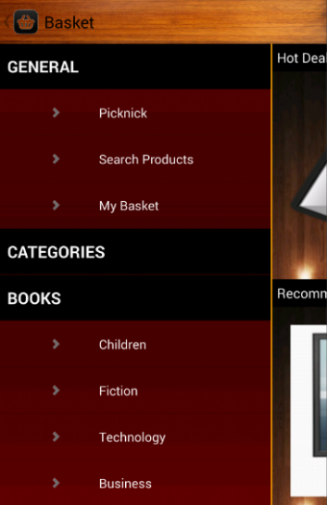  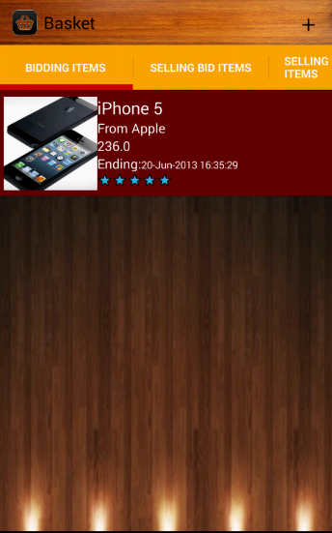

**Selling products**

1. Login with a valid account username and password.
2. On the homepage swipe to the right or touch the Basket action button to open the side menu.
3. Select the Picknick option.
4. On the Picknick screen select the My Shop option.
5. Press the plus sign on the top right corner of the screen.
6. Select the “Sell Product” option.
7. Enter all the product information.
8. Press “Sell Product”

  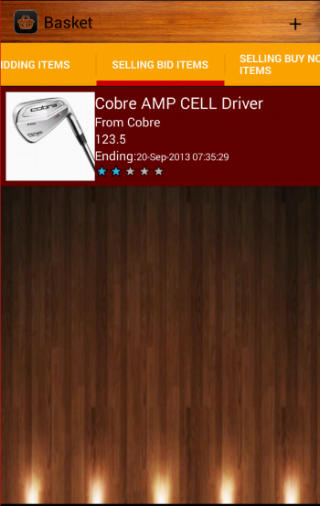

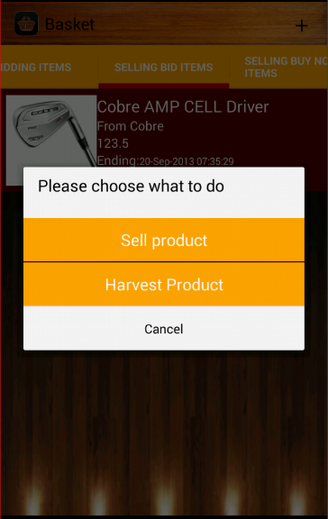 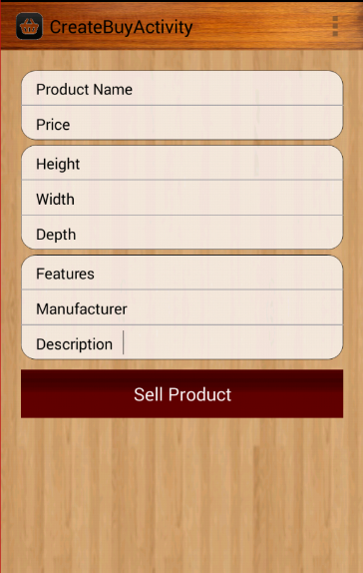

**Auctioning products**

1. Login with a valid account username and password.
2. On the homepage swipe to the right or touch the Basket action button to open the side menu.
3. Select the Picknick option.
4. On the Picknick screen select the My Shop option.
5. Press the plus sign on the top right corner of the screen.
6. Select the “Harvest Product” option.
7. Enter all the product information.
8. Press “Sell Product”

  

 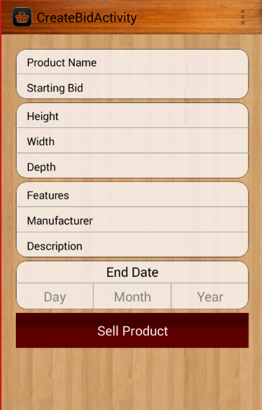

**Bidding**

1. Login with a valid account username and password.
2. Search for a product you want to bid on.
3. Open the product's screen by selecting it.
4. Go to the harvest tab and on the harvest field enter the amount to be bid on the product.

  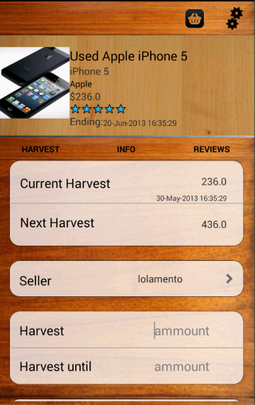

**Adding a buy now product to a basket**

1. Login with a valid account username and password.
2. Search for a product you want to add to a basket.
3. Open the product's screen by selecting it.
4. Press the Add to Basket button in the bottom of the screen.
5. If more than one basket is available you will be prompted to choose one to place the item in.

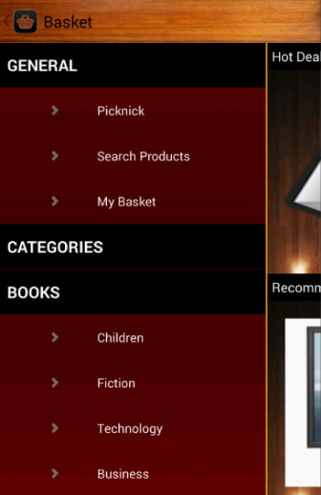 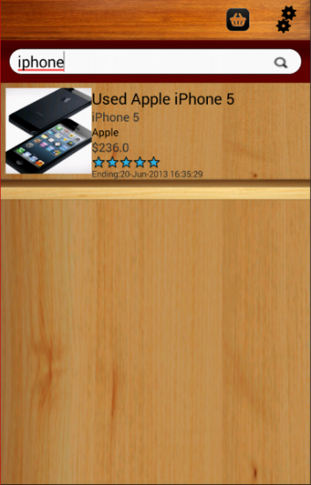 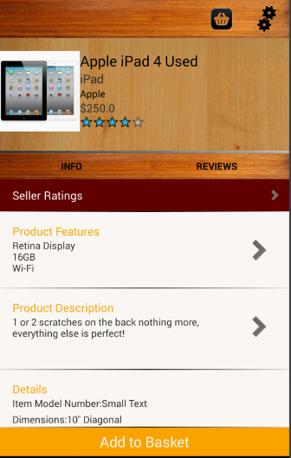 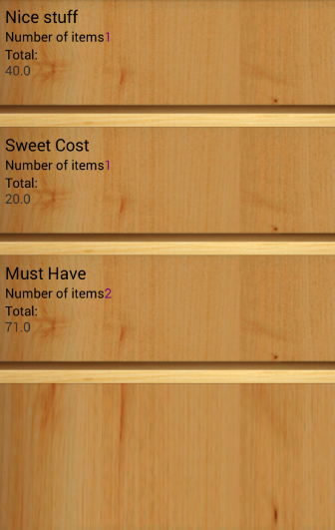

**Viewing Product Info**

1. Login with a valid account username and password.
2. Search for a product you want to bid on.
3. Open the product's screen by selecting it. Go to the "Info" tab to see the product's information.
4. The product's information includes: name, manufacturer, price, features, description, model, and dimensions.

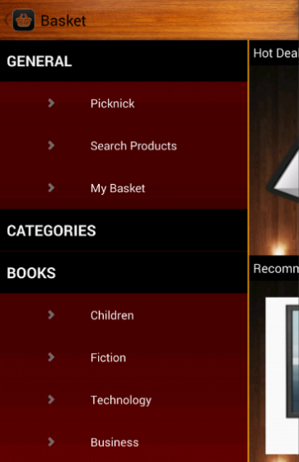  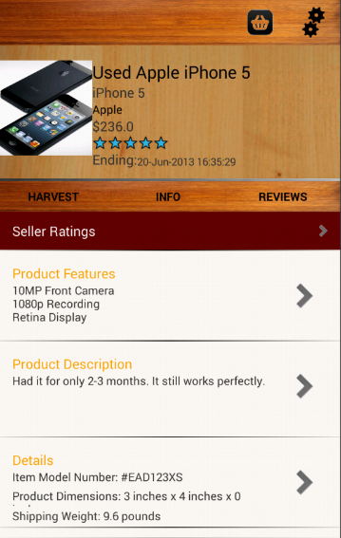

**Viewing product review**

1. Login with a valid account username and password.
2. Search for a product you want to bid on.
3. Open the product's screen by selecting it. Go to the "Reviews" tab to see the product's reviews.

  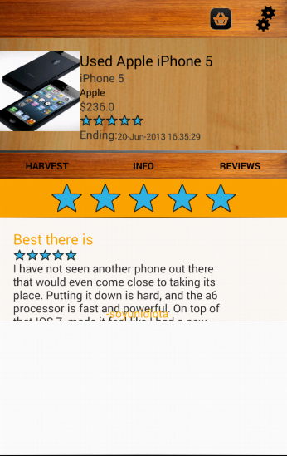

**Browsing categories**

1. Login with a valid account username and password.
2. On the homepage swipe to the right or touch the Basket action button to open the side menu.
3. Select the category to browse.
4. Select subcategory if applicable
5. In the category page products can be searched and the search filter can be used.

 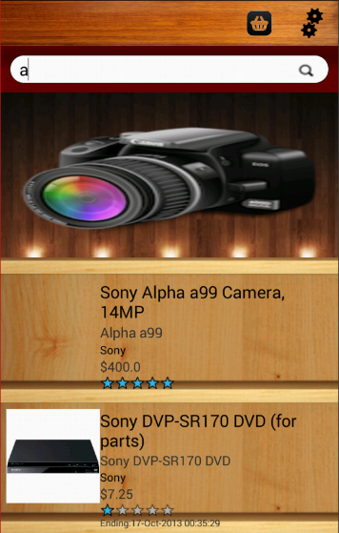 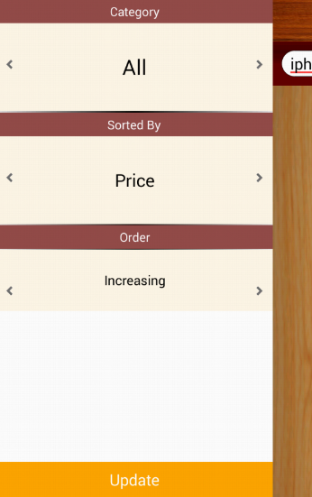

**Accepting bids**

1. Login with a valid account username and password.
2. On the homepage swipe to the right or touch the Basket action button to open the side menu.
3. Select picknick.
4. Select My Shop
5. In the Bidding items page pull to refresh to see if a product is won
6. Click the product and decide to accept or deny it

  

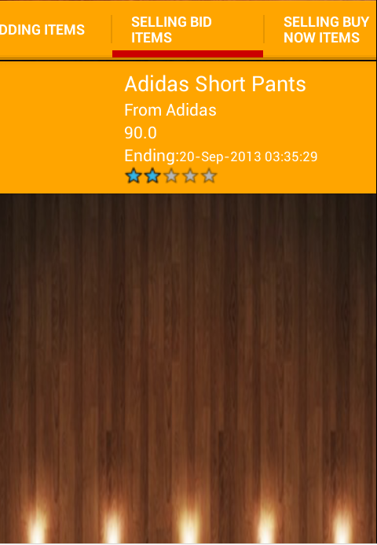 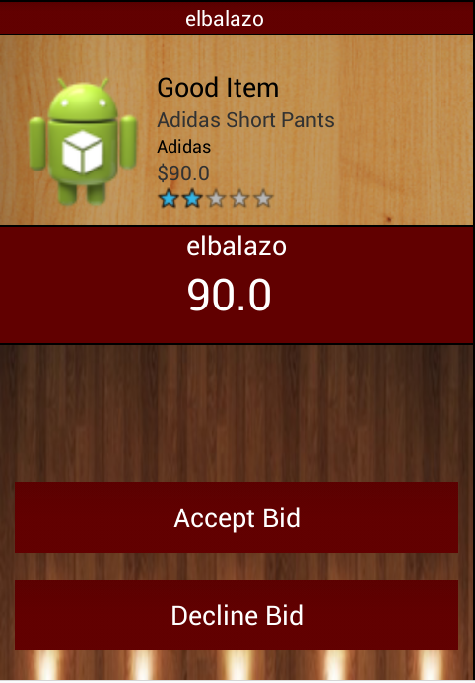

**Administrators**

**Creating an account**

1. Login with an administrator account. These are distinctive for the “@” at the beginning of their username
2. Select the “Create Account” option in the administrator menu.
3. Fill out all the necessary information for the new user.
4. Check the Admin checkbox at the end of the form if the user will have administrator privileges.
5. Press “Create Account

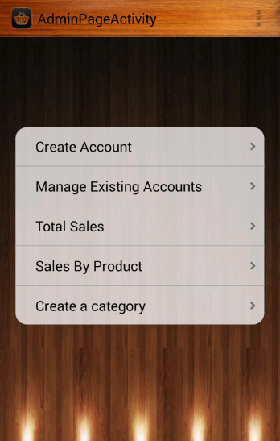 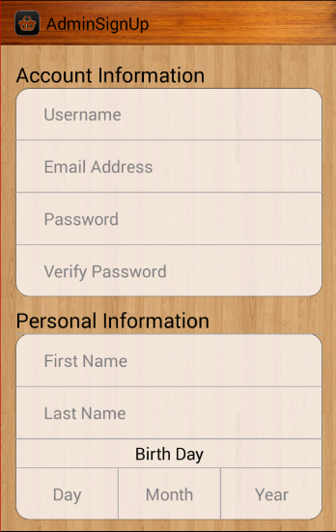 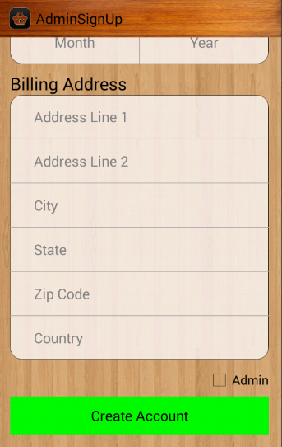

**Managing existing accounts**

1. Login with an administrator account. These are distinctive for the “@” at the beginning of their username
2. Select the “Manage Existing Accounts” option in the administrator menu.
3. Select the user to be managed.
4. The user information can be edited by entering the new value in the corresponding text box.
5. The user can be deleted by pressing the “Delete Account” button.

 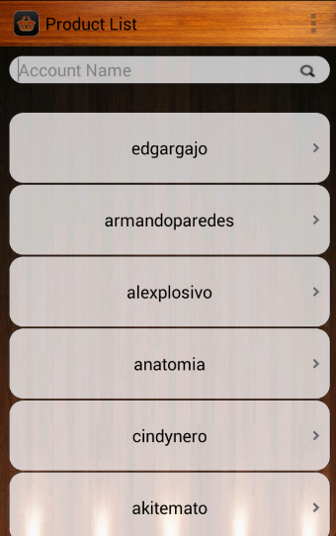 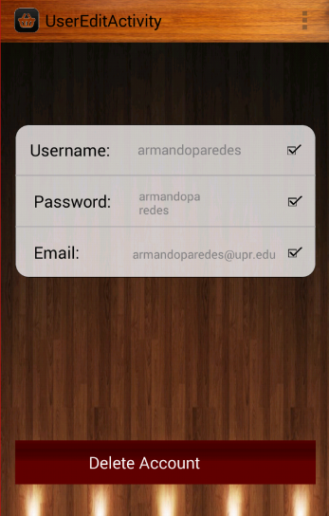

**Viewing total sales and revenue**

1. Login with an administrator account. These are distinctive for the “@” at the beginning of their username
2. Select the “Total Sales” option in the administrator menu.
3. Select the date to see the total sales and revenue around that date
   1. Select “Year” to see the sales and revenue in the selected year.
   2. Select “Month” to see the sales and revenue in the selected month.
   3. Select “Week” to see the sales and revenue in the selected week.
   4. Select “Day” to see the sales and revenue in the selected day.

 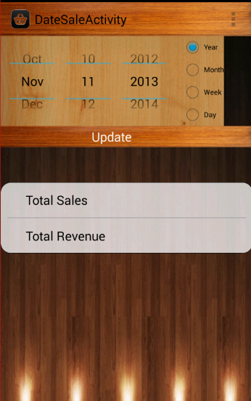

**Viewing sales by product**

1. Login with an administrator account. These are distinctive for the “@” at the beginning of their username
2. Select the “Sales by Product” option in the administrator menu.
3. Enter the name of the product in the search box

 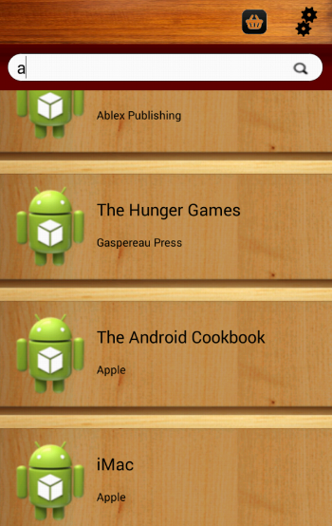

**Creating a new category**

1. Login with an administrator account. These are distinctive for the “@” at the beginning of their username
2. Select the “Create a Category” option in the administrator menu.
3. Type the main category name and its subcategory name on the space provided.
4. Press the “Create Category” button.

 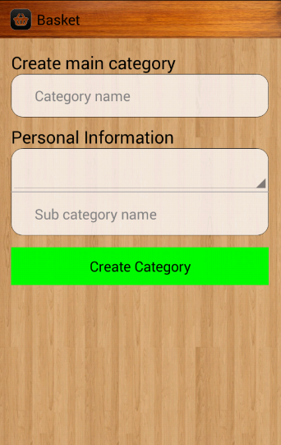

**Explanation of the entities and relationships of the ER Diagram of "Basket"**

* Entities:
  + User: An entity that represents the user of the application.
    - User Id: Unique identification code generated for searching users in the database.
    - Username: Unique identification set by the user so that he can start the session.
    - E-Mail: User’s email for communication purposes and notifications.
    - Password: Password for the purpose of protecting user information.
    - First name, Last name, Birthday and Age: The user’s name, birthday and age.
  + Admin: Entity that represents the user with privileges to manage users and other aspects of the application.
    - User Id: Unique identification code generated for searching users in the database.
    - Username: Unique identification set by the user so that he can start the session.
    - E-Mail: User’s email for communication purposes and notifications.
    - Password: Password for the purpose of protecting user information.
    - First name, Last name & Age: The user’s name and age.
  + Address: Entity that represents an address either for shipping or billing.
    - Address Id: Unique identification code generated for searching the database.
    - Address Lines: Part of identifying the street address, apartment, sector, etc.
      * Line 1 and Line 2
    - City: City of the address.
    - State: State address if it is in the United States.
    - Zip Code: The address’ zip code.
    - Country: Country of the address.
  + Bank Account: An entity that represents the bank account information of the user, which is used for receiving payments from other users for a product in sale.
    - Bank Account Id: Unique identification code generated for searching the database.
    - Account Number: Number of the user's bank account.
  + Credit Card: An entity that represents information of a credit card, used as a user payment option.
    - Credit Card Id: Unique identification code generated for searching the database.
    - Credit Card Number: Number of the user's credit card.
    - Security Code: Security Code of the credit card to make payments.
    - Exp. Date: Expiration date of the credit card.
      * Month & Year
    - Cardholder Name: Name of the owner of the credit card exactly as it appears on the card.
    - Billing Address: Address tied to the credit card where bills are sent.
  + Order: Entity that represents a transaction where a payment is made for one or more products within a cart or "Basket".
    - Order Id: Unique identification code generated for searching the database.
    - Amount: Total amount to pay.
    - Type: Whether it’s a bid or buy event order.
    - Date: Date on which the transaction is completed.
    - Time: Time in hours and minutes in which the transaction is completed.
  + Basket: Entity that represents a basket in which one or more products are placed for the purpose of a future purchase.
    - Basket Id: Unique identification code generated for searching the database.
    - Name: Name of the basket so that the user can identify the baskets together.
  + Buy Event: Entity that represents a sale, for the seller, and a purchase, if the purchaser of a product.
    - Buy Event Id: generated unique identification code for searching the database.
    - Price: Product price specified by the seller.
    - Selling Time: Date and time at which performs such purchase / sale is made.
    - Description: Description of the product being sold.
    - Title: Title set by the seller to attract buyers.
    - Picture: Picture of the product being sold or auctioned.
    - Available: Current available stock.
    - Buy Category: The category of the product being sold
  + Bid Event: Entity that represents an event of auction in which the highest bettor wins if your product meets the minimum bet the seller.
    - Bid Event Id: generated unique identification code for searching the database.
    - Starting bid: Amount at which the bidding will start.
    - Minimum Bid: Minimum bet that that current winning bet must beat so that the product is officially won.
    - Time:
      * Starting: Time at which the auction was started.
      * Ending: Time in which the auction is set to end, at which time the greatest gambler, if you meet the minimum bet, wins the auction.
    - Title: Title set by the seller to attract buyers.
    - Picture: Picture of the product being sold or auctioned.
    - Description: Description of the product being sold.
    - Bid Category: The category of the product being auctioned.
  + Product: Entity that represents a product to be sold or auctioned by a user.
    - Product Id: generated unique identification code for searching the database.
    - Seller Product Id: identification code established by the seller.
    - Name: Name of the product.
    - Features: Features of the product.
    - Dimensions: Dimensions of the product.
  + Manufacturer: Entity that represents a product manufacturing.
    - Manufacturer Id: generated unique identification code for searching the database.
    - Name: Name of the manufacturer.
  + Category: Entity representing a category in which you group multiple products with similar characteristics.
    - Category Id: generated unique identification code for searching the database.
    - Name: Name of the category.
  + Review: An entity that represents a review submitted by a user of a product or another user as a seller.
    - Review Id: generated unique identification code for searching the database.
    - Title: Title of the summary describing briefly the contents of the review.
    - Rating: Method for measuring the quality of the product or seller based on 5 stars, where 5 is the best quality and 1 is the lowest quality.
    - Content: Body of review on which specific good and bad points of the product or seller.
* Relationships:
  + Manages: Relationship between Admin and User entities symbolizing one or more administrator(s) managing one or more user(s).
    - This relationship is many-to-many because a user can be managed by one or more administrators and an administrator can manage one or more users.
    - User has full participation because all users must be managed by an administrator.
    - Admin has partial participation as it may be an administrator manage any user without an example of this case would be the beginning of the creation of the application where there are no users yet.
  + With Shipping
    - This relationship is one-to-many because a user can have multiple shipping addresses but a shipping address can belong to one.
    - User has full participation because every user must have at least one shipping address.
    - Address has full participation because all shipping address must be associated with a user.
  + With Billing
    - This relationship is one-to-one because a credit card can only have a billing address, and a billing address belongs to one credit card.
    - Credit Card has full participation because all credit card must be related to one and only one billing address.
    - Address has full participation because all billing address must be associated with at least one credit card.
  + Has Bank Account
    - This relationship is one- to-many and a user can have multiple bank few related but a bank account can only be related to a user.
    - User has partial participation because it can be as much user without related bank.
    - Bank Account has full participation because all bank account must be related to one and only one user.
  + Deposits To
    - This relationship is one-to-many because an order can only deposit to one bank account but a bank account can receive deposits from multiple orders.
    - Bank Account has partial participation as it may exist without a transaction deposit.
    - Transaction has total participation because if there is a transaction then it must receive a deposit of at least one and only one bank account.
  + From Bank Account
    - This relationship is one-to-one since a credit card can only be linked to a bank account and a bank account can only be linked to a credit card.
    - Credit Card has full participation because if there is a credit card this must be related to one and only one bank account.
    - Bank Account has partial participation because a user can have a bank account without it being related to a credit card.
  + Performs an Order
    - This relationship is one-to-many because a user can complete a transaction but several transactions can only be executed by a user.
    - User has partial participation because a user is not required to execute a transaction.
    - Transaction has full participation and that any transaction must be completed by one and only one user.
  + Has Credit
    - This relationship is one-to-many because credit cards can only be linked to a user but a user can have multiple credit cards.
    - User has full participation as it is mandatory for a user to have a credit card linked to it.
    - Credit Card has full participation because all credit card must be related to one and only one user.
  + With Credit Card
    - This relationship is one-to-many and represents a single transaction paid with a credit card, but a credit card can pay more transactions.
    - Credit Card has partial participation as not all credit card is required to pay a transaction,
    - Transaction has total participation because if a transaction is to be paid with one and only one credit card.
  + Has Basket
    - This relationship is one-to-many and represent as a user may have several baskets, but a basket can only belong to a user.
    - User has partial participation because it is not mandatory that each user has a basket.
    - Basketball has full participation because all basket must belong to one and only one user.
  + Concludes Baskets
    - This relationship is one-to-one and represented as a transaction pays for a basket.
    - Transaction has full participation because any transaction must pay for one and only one basket.
    - Basketball has partial participation because the user has the option whether or not to buy a basket.
  + Creates Buy Event
    - This relationship is one-to -many and represents as a user can create several sales, but sales events only belong to a user or seller in this case.
    - User has partial participation as it is not mandatory that all users put products on sale.
    - Buy Event has full participation because all sales event must be created by one and only one user.
  + Creates Bid Event
    - This relationship is one-to-many and represents as a user can create multiple auctions, but auction event belongs only to a user or in this case auctioneer.
    - User has partial participation as it is not mandatory that all users put products in auction.
    - Buy Event has full participation because all auction event must be created by one and only one user.
  + In Buy Basket
    - This relationship is many-to-many and represents how buy events are in a basket.
    - Buy Event has partial participation as there may be sales events that are not purchased.
    - Basket has partial participation as there may be empty baskets.
    - This relationship has the attribute Item Quantity that specifies the number of products to be bought.
  + In Bid Basket
    - This relationship is many-to-many and represents how bid events are in a basket.
    - Bid Event has partial participation as there may be events that are not bid on.
    - Basket has partial participation as there may be empty baskets.
  + With Bid
    - This relationship is one-to-many and represents the bets made at auction.
    - Bid has full participation as any bet must be made ​​on an auction event.
    - Bid Event has partial participation, and there may be an auction not receiving bets.
  + With Winning
    - This relationship is one-to-one and represents as an auction event has a single winning bet.
    - Bid Event has partial participation, because an auction event may not receive bets.
    - Bid has full participation as any bet must be made ​​on an auction event.
  + In Buy Event
    - This relationship is one-to-many and represented as each instance of each product can be in a sale event but several sale events can have the same product.
    - Buy Event has full participation because all sales event set must have one and only one product.
    - Product has partial participation since not all existing product is sold.
  + In Bid Event
    - This relationship is one-to -many and represented as each instance of each product may be in an auction event but several auction events can have the same product.
    - Bid Event has full participation because all auction event set must have one and only one product.
    - Product has partial participation since not all existing product is auctioned.
  + Made By
    - This relationship is one-to -many and represented as a manufacturer can manufacture various products but a product belongs to a manufacturing one.
    - Manufacturer has partial participation because not everything has existing manufacturing products.
    - Product has full participation as a product was manufactured by one and only one manufacturer.
  + Belongs to
    - This relationship is one-to -many and represented as a category has many products but a product belongs to only one category.
    - Subcategory has partial participation as there may be subcategories empty.
    - Product has full participation and that all products must belong to one and only one subcategory.
  + From Parent Category
    - This relationship is one-to-many and represents as a category can have several subcategories but a subcategory may belong to a single category.
    - Category has partial participation as there may be categories without subcategories.
    - Sub has full participation because all subcategory must belong to a category.
  + Bids
    - This relationship is one-to-many and represented as a user may have several bets but every bet belongs to a single user.
    - User has partial participation since not all user makes a bet.
    - Bid has full participation because all bets created must belong to a user.
  + Is Reviewed
    - This relationship is one-to-many because each user is reviewed by several reviews but each review is for only one user.
    - Review has full participation as any review must be for one and only one user
    - User has partial participation as not all users are outlined
  + Submits
    - This relationship is one-to-many and represents as every user can submit multiple reviews but a review can be submitted only by a user.
    - User has partial participation since not all users submit reviews.
    - Review has total participation since everything is under review by one and only one user.
  + Reviews Buy Event
    - This relationship is one-to-many and represents as a product may be reviewed more than once, but each review is only for a product.
    - Review has full participation because all product review must be for one and only one product.
    - Product has full participation as not all products are reviewed.
  + Reviews Bid Event
    - This relationship is one-to-many and represents as a product may be reviewed more than once, but each review is only for a product.
    - Review has full participation because all product review must be for one and only one product.
    - Product has full participation as not all products are reviewed.

Entity Relationship Diagram:

